Solution: Queries

In this lab, you will write queries using the Guidewire API and Gosu.

Requirements

This lab requires that you use TrainingApp 8.0, Guidewire Studio 8.0, and Gosu Scratchpad.

1. Write Queries

In this exercise, you will write queries using the Guidewire API and Gosu Scratchpad to retrieve specific TrainingApp data.

Tasks

1. Open Guidewire Studio for TrainingApp
2. From Studio, if your server is not already running, start the server using Debug 'Server'.
3. Review the Debug console for errors and verify that the application is running in the Debug console.
4. Open Gosu Scratchpad.
5. Querys:
6. The first and last name of all the ABAttorneys.  
   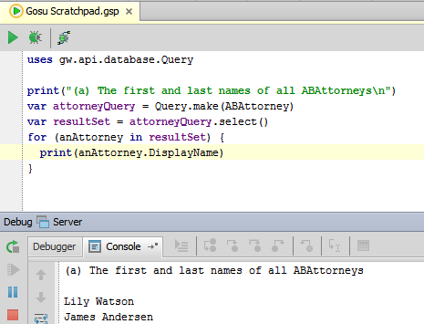

uses gw.api.database.Query

print("(a) The first and last names of all ABAttorneys\n")

var attorneyQuery = Query.make(ABAttorney)

var resultSet = attorneyQuery.select()

for (anAttorney in resultSet) {

print(anAttorney.DisplayName)

}

1. The last name of all ABPersons whose first name is Paul.   
   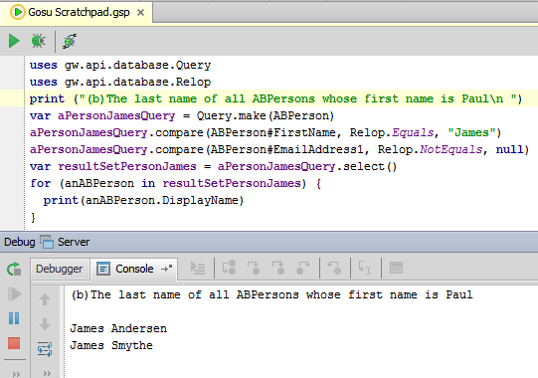

uses gw.api.database.Query

uses gw.api.database.Relop

print ("(b)The last name of all ABPersons whose first name is Paul\n ")

var aPersonJamesQuery = Query.make(ABPerson)

aPersonJamesQuery.compare(ABPerson#FirstName, Relop.Equals, "James")

aPersonJamesQuery.compare(ABPerson#EmailAddress1, Relop.NotEquals, null)

var resultSetPersonJames = aPersonJamesQuery.select()

for (anABPerson in resultSetPersonJames) {

print(anABPerson.DisplayName)

}

1. The name of all ABPersons whose first name is "James" and whose email address is not null.  
   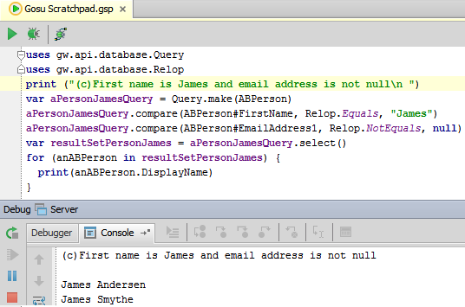

uses gw.api.database.Query

uses gw.api.database.Relop

print ("(c)First name is James and email address is not null\n ")

var aPersonJamesQuery = Query.make(ABPerson)

aPersonJamesQuery.compare(ABPerson#FirstName, Relop.Equals, "James")

aPersonJamesQuery.compare(ABPerson#EmailAddress1, Relop.NotEquals, null)

var resultSetPersonJames = aPersonJamesQuery.select()

for (anABPerson in resultSetPersonJames) {

print(anABPerson.DisplayName)

}

1. The name of all ABPersons whose first name is "James" or whose email address is not null.  
   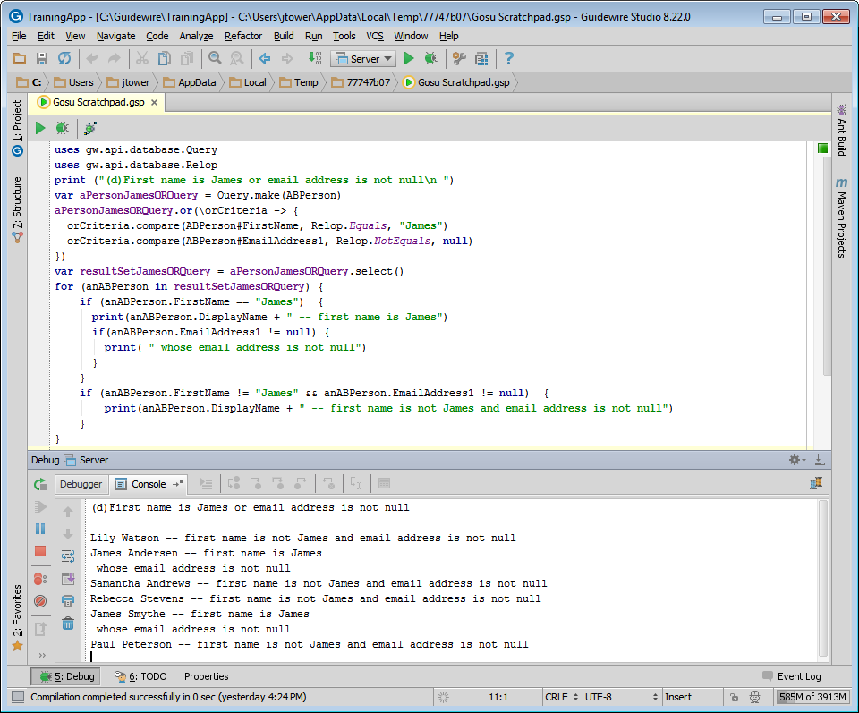

uses gw.api.database.Query

uses gw.api.database.Relop

print ("(d)First name is James or email address is not null\n ")

var aPersonJamesORQuery = Query.make(ABPerson)

aPersonJamesORQuery.or(\orCriteria -> {

orCriteria.compare(ABPerson#FirstName, Relop.Equals, "James")

orCriteria.compare(ABPerson#EmailAddress1, Relop.NotEquals, null)

})

var resultSetJamesORQuery = aPersonJamesORQuery.select()

for (anABPerson in resultSetJamesORQuery) {

if (anABPerson.FirstName == "James") {

print(anABPerson.DisplayName + " -- first name is James")

if(anABPerson.EmailAddress1 != null) {

print( " whose email address is not null")

}

}

if (anABPerson.FirstName != "James" && anABPerson.EmailAddress1 != null) {

print(anABPerson.DisplayName + " -- first name is not James and email address is not null")

}

}

1. The number of ABCompanies.   
   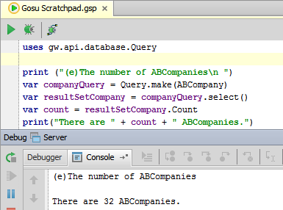

uses gw.api.database.Query

uses gw.api.database.Relop

print ("(e)The number of ABCompanies\n ")

var companyQuery = Query.make(ABCompany)

var resultSetCompany = companyQuery.select()

var count = resultSetCompany.Count

print("There are " + count + " ABCompanies.")

1. The names of all ABCompanies where the companies are ordered by name.   
   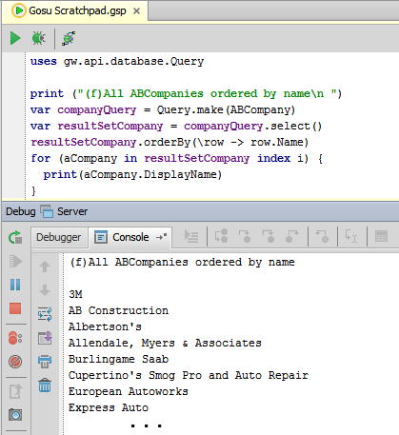

uses gw.api.database.Query

print ("(f)All ABCompanies ordered by name\n ")

var companyQuery = Query.make(ABCompany)

var resultSetCompany = companyQuery.select()

resultSetCompany.orderBy(\row -> row.Name)

for (aCompany in resultSetCompany index i) {

print(aCompany.DisplayName)

}

|  |  |
| --- | --- |
|  | Stop and ask your instructor to review your completed lab. If needed, compare your code with the available solution set. |